Lab Assignment 1

Introduction:

This lab assignment mainly focuses on the usage of List, Classes and String formatting

Objectives

Objective of this assignment is to get familiar with all the concepts covered and write python code for each of the requirement

Approach

Each requirement needed different approach in coding.

The first requirement was to use loops to validate a password entered by the user.

The code sample and output for this are as follows:

Here the requirement was that the password entered should have an upper-case letter, a number, a special symbol and length of the password should be more than 6 characters but less than 16 characters.

Firstly, we need to check if the password satisfies the password length requirement (used the len() for this). Next check if it has at least one symbol if the condition satisfies check if it has at least one lower case letter, one upper-case and at least one integer/number else prompt the user with appropriate error message at each failed condition and allow the user to enter the password again this can be achieved using a while loop. Loop till all the conditions in IF statement is satisfied. On success, prompt the user that the password has been saved.

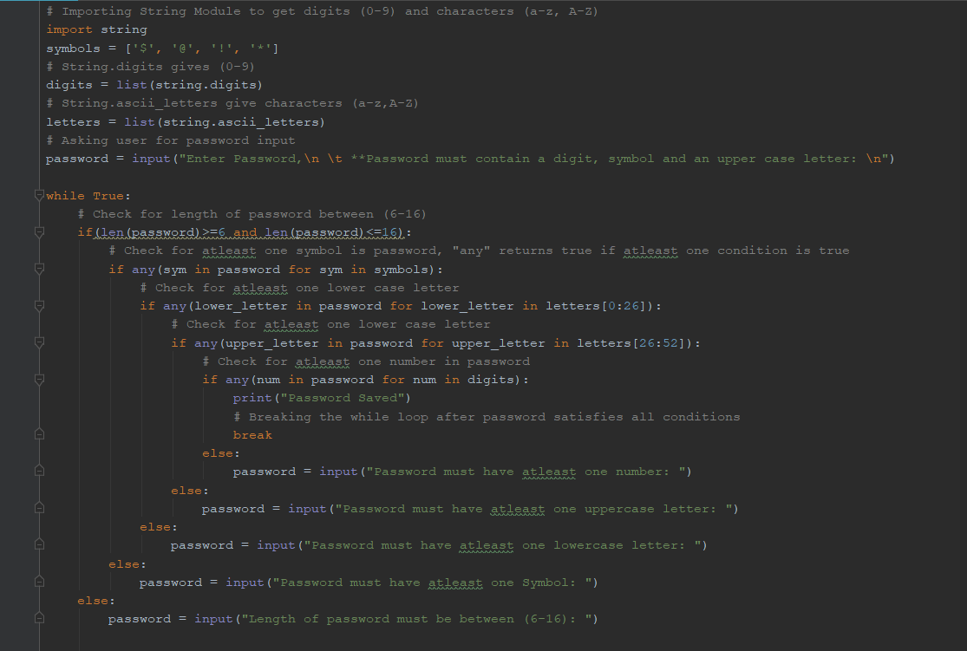

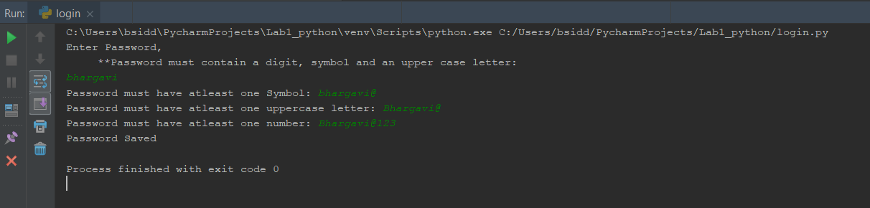

Second requirement was to perform string formatting to get the middle word, longest word and to reverse the sentence entered by the user. Code sample and output is:

Firstly, read the input from the user. Split each word using the split function and saved result into a list, which makes it easier to work with each word.

To get the middle word of the sentence, get the length of the list, if its even number print the elements that are at (list length)/2 and(list length/2)+1 position. If the length is an odd number just print the middle element.

Longest word in the sentence: Append the length of each word in one list to another list. Next get the index of highest number of the second list, and print the element present at that index from the first list.

Reverse sentence : As the last character in a string has an index of -1. If we use it as follows to reverse the entire sentence.

T

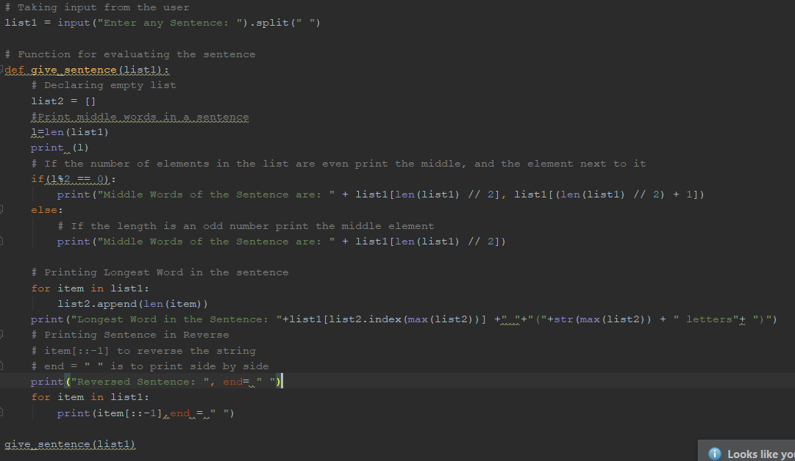

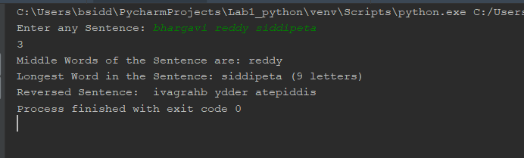

Next to print all the triplets in the list which gives sum of 0, screenshots are the same are as follows:

Consider any list with positive and negative integers so that the sum of any three numbers make Zero.

Then start looping through each element in the list so that no two consecutive elements are same and check if sum of the three elements make a Zero.

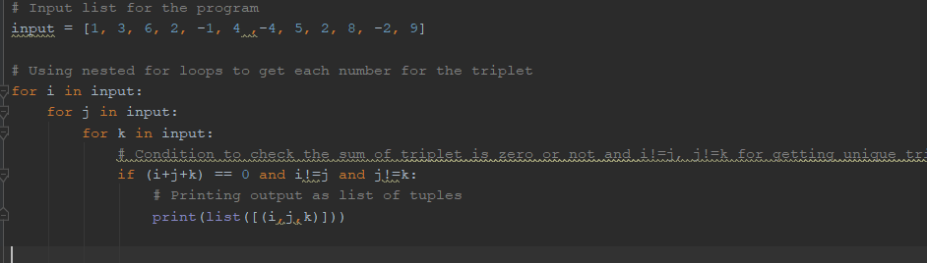

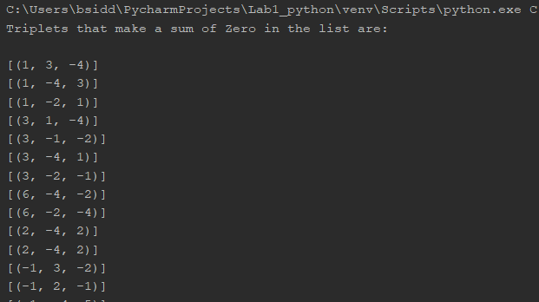

To get the list of students enrolled in both Python, Web Application and who are not common in both classes, the code sample is:

Consider 2 lists, each for one subjects having a set of students enrolled for the same.

To print students who are attending the both classes, loop through one list and check if they are present in the second list. If yes print the student name else go to next element.

To get the students who are not common iterate through first list and check if they are not present in the second, print. Repeat the same logic on the second list as well.

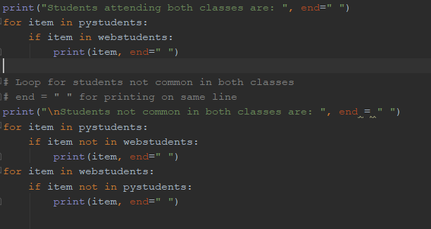

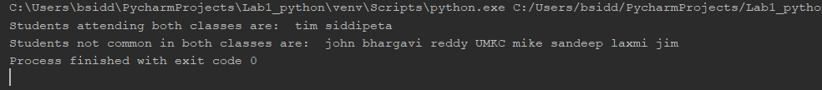

Python program which displays the Airline and Hotel booking id for a user is:

To achieve this classes have been used, where each class has its own functionality.

User input is taken and checked if there are any flights and hotels available on the departure date. If so then booking id, Hotel number, Airline name are displayed according to the availability.

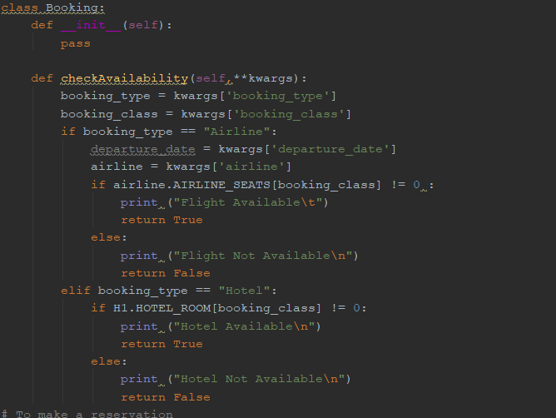

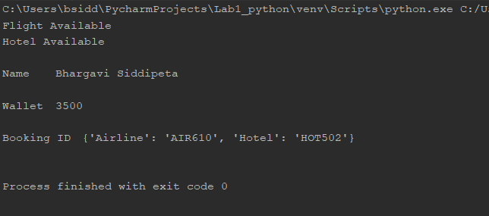

To get the most occurred element in a list, the following logic has been used.

Generate a list of size 15 with numbers between 0 and 20 randomly using random which a build function under the library numpy.

Display the number of times each element is occurred in the list and then display the number that has the highest occurrence frequency using **bincount().argmax()** under numpy library

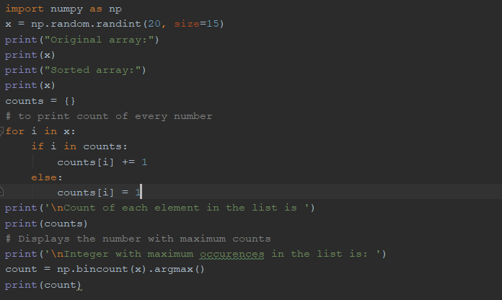

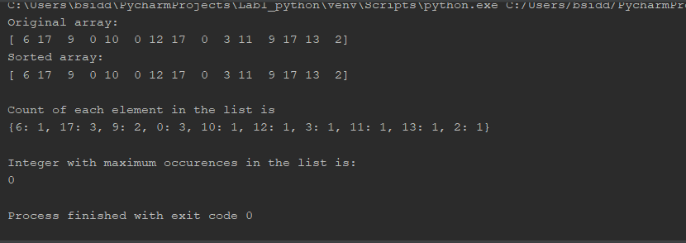

Workflow

Datasets

Parameters

https://youtu.be/_mOQ0qxNYWk

Evaluation

Conclusion